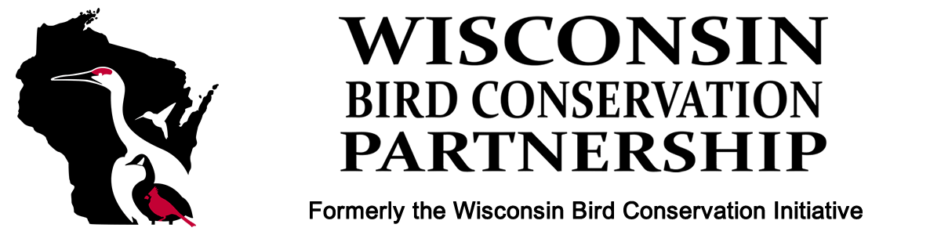

REQUEST FOR PROPOSALS

The Wisconsin Bird Conservation Partnership (WBCP) is announcing a Request for Proposals (RFP) to advance bird conservation within the Wisconsin Important Bird Area (IBA) system.
From 2020 to 2022, WBCP conducted a series of evaluations to prioritize IBAs that are best positioned to deliver a high level of bird conservation. Projects that propose key actions in these IBAs will be prioritized for funding. However, recognizing the value of all IBAs, WBCP will also consider funding for all conservation actions in any IBA.
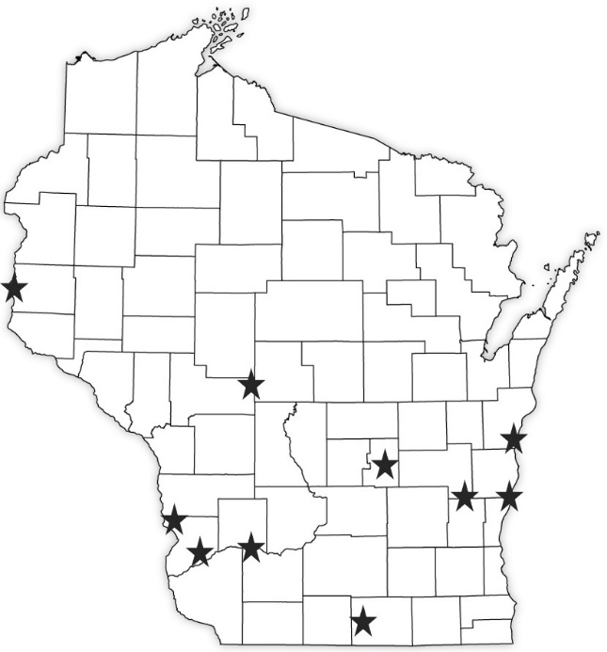
Priority IBAs
These IBAs have addressable targeted actions that will combine with an existing resilient and stable backdrop to improve bird conservation where it is most needed:
Avon Bottoms
Bear Bluff Peatlands
Cleveland Lakeshore Migration Corridor
Grand River Marsh-Grassland
Harrington Beach Lakeshore Migration Corridor
Lower Kickapoo River
Lower Wisconsin River
North Kettle Moraine State Forest
Rush Creek Forest-Prairie
St Croix River

See the Excel spreadsheet at the end of this announcement for a table of actions for priority IBAs.

Non-priority IBAs
Actions to improve conservation in non-priority IBAs will also be considered for funding, and may include but are not limited to the following actions:
Initiate local partnerships
- Supplies, travel, materials, rental space for meetings, partnership coordinator support

Private lands communication
- Outreach/education to landowners
- Hosting meetings (bringing in speakers) that explain bird conservation needs and the importance of IBAs
- Trails, signage, other interpretive materials

Improving habitat
- Restoration or management of forests, wetlands, grasslands, or other native habitats
- Native plant gardens and plantings
- Invasive species control and management
- Nest box trails for unique species (if applicable)

Threats
- Education and outreach regarding habitat loss, cat predation, window collisions, invasive species, and other threats to birds
- Window treatments to reduce collisions
- Climate change mitigation projects

Inventory & Monitoring
- Hiring technicians for targeted surveys
- Organizing community/citizen science events or monitoring programs
- Equipment and supplies

Funding Details
Applicants can apply for up to $10,000 in funds to be used over a 1-year grant cycle.
Matching funds are not required; however, it will be advantageous for an applicant to show these funds will be supplemented by partner dollars or leveraged for future funding.
Ideally, we are seeking organizations working collaboratively with multiple partners or who are interested in initiating collaborative conservation action within a designated Wisconsin Important Bird Area. Our goal is to accelerate bird conservation delivery within IBAs by supporting partner-driven action.
Recipients must be able to justify and demonstrate conservation objectives, outcomes, and clear measures of success stemming directly from the awarded funds.
All bird data collected with awarded funds must be entered in eBird.
A final report must be submitted documenting the conservation outcomes and measures of success at the completion of the award.
WBCP requests permission to feature the funded projects on the WBCP website and on social media.
WBCP will provide advice and technical support as needed to the awardees and their partners.

Application Instructions & Requirements
Please provide the following information in ONE Microsoft Word file that reflects the following information in individual sections. You will have an opportunity to provide a project narrative under number 12 below.
- Proposal title
- One sentence project summary statement
- List three key words that describe your project.
- Information for all applicants and project staff (name, title, organization, address, phone, email, website) as well as qualifications.
- Anticipated project start and end dates
- Geographic area where work will take place (IBA/county)
- If WBCP funds will be paired with other funds, briefly describe the amount and source.
- List of partners or potential partners
- Clearly stated objectives and long-term conservation outcomes
- Bird species that will benefit from your proposed work
- Land area (acres) and habitat types that will be improved, managed, or protected
- Project Narrative: a brief description (1 page maximum) of your strategy for achieving your objectives and conservation outcomes. What are your measures of success?
- Provide a simple budget for the proposed project. Note: if these funds are part of a larger project’s budget, please clearly outline the use of the funds within the larger project.
Applications are due October 01, 2023, with funds awarded by November 15, 2023.

Send application materials to Craig.Thompson@wisconsin.gov .

For questions about specific IBAs or the IBA evaluations contact:
Tom Prestby
Wisconsin Conservation Manager
Audubon Great Lakes
Green Bay, WI
thomas.prestby@audubon.org
414.614.0798

For questions related to the RFP contact:

Craig Thompson
Natural Heritage Conservation Program
Wisconsin Department of Natural Resources
La Crosse, WI
Craig.Thomspon@wisconsin.org
608.304.2383

